Project Title
Smart EduBot
By
Aafia & Nabisha Haider
Roll No: 123352 & 123355
Session: 2022-2026
Supervisor: Mr. Ghulam Ghos



Department of Information Technology, GC University Faisalabad

January 2026
Certificate of Approval
This is to certify that the project titled "Smart EduBot" submitted by AAFIA & NABISHA HAIDER (Roll No: 123352 & 123355) in partial fulfillment of the requirements for the degree of Bachelor of Science in Information Technology has been examined and approved.

Name: Mr. Ghulam Ghos
Signature: _______________
Date: ___________________

Name: Dr. Maroof Pasha
Signature: ______________
Date: __________________

Declaration
I hereby declare that this project titled "Smart EduBot" is my own work and has not been submitted elsewhere for any other degree or qualification

Name: AAFIA
Roll No: 123352
Signature: _____________
Date: _________________

Name: NABISHA HAIDER
Roll No: 123355
Signature: _____________
Date: _________________

Acknowledgements
All praise, thanks, glorification, and gratitude are for ALLAH Almighty. I achieved my goal by ALLAH’s infinite mercy and grace. I say Alhamdulillah for HIS uncountable blessings. After ALLAH, thanks to last Prophet Muhammad (ﷺ) who guided us toward the right path. Beloved prophet (ﷺ) says “Education is equally important for men and women”.
Very special and humble thanks to my father. He is my main supporter to continue the studies. My father instilled iron determination in me. I just want to say, he is great, he is genius. I also express special thanks to my mother. She always prayed for me and improves my confidence to continue the higher study. My mother has always been very caring about my health, studies, and career. I would like to pay my heartiest gratitude to my sister and brothers for being a great source of support and encouragement to complete this work. Especially, thanks to my brothers who guided and helped me all along the way.
I would like to express my sincere gratitude to my supervisor Mr. Ghulam Ghos for the continuous support of my research work, for their patience, motivation, enthusiasm, and immense knowledge. Their guidance helped me during all the time of research and writing of this thesis. I could not have imagined having a better advisor and mentor for my research work.
Secondly, I would like to say thanks to Mam Aliya Bodla, principle and director of Regional Institute of Allied Health Sciences and Higher Education, Mian Channu, whose support and concern towards students is highly valuable.
In addition, I would like to acknowledge important role of Mr. Usman, whose help and assistance remained a source of motivation for me throughout this task.

AAFIA
123352
NABISHA HAIDER
123355

Abstract
This paper presents an Smart EduBot...

TABLE OF CONTENTS
Chapter 1: Introduction 1
1.1 Project Overview 1
1.2 Problem Statement 1
1.3 Project Motivation 1
1.4 Aims and Objectives 2
1.5 Project Scope 2
1.6 Document Structure 3
Chapter 2: Literature Review & Background Study 4
2.1 Introduction to the Domain 4
2.2 Existing Systems Analysis 5
2.3 Comparative Analysis 6
2.4 Identified Research Gaps 6
2.5 Proposed Solution Overview 7
Chapter 3: Requirement Analysis & Specification 8
3.1 Stakeholder Analysis 8
3.2 Functional Requirements 8
3.3 Non-Functional Requirements 10
3.4 Use Case Modeling 11
3.5 User Stories 14
3.6 Hardware and Software Requirements 14
Chapter 4: System Design 16
4.1 Design Principles and Methodology 16
4.2 System Architecture 16
4.3 Data Storage Design 17
4.4 API Design 17
4.5 Process Design 19
4.6 Security Design 21
4.7 UI/UX Design 21
Chapter 5: Implementation & Development 24
5.1 Development Environment Setup 24
5.2 Backend Module Implementation 25
5.3 Frontend Module Implementation 27
5.4 Key Code Explanations 28
5.5 Challenges Faced and Solutions 29
Chapter 6: Testing & Validation 30
6.1 Testing Strategy 30
6.2 Functional Test Cases 30
6.3 Edge Case Testing 32
6.4 Testing Summary 32
Chapter 7: Results & Discussion 34
7.1 System Implementation Results 34
7.2 Achievement of Objectives 39
7.3 Performance Evaluation 40
7.4 Discussion 40
7.5 Limitations Encountered 41
Chapter 8: Conclusion & Future Work 42
8.1 Conclusion 42
8.2 Limitations 42
8.3 Future Enhancements 42
8.4 Social Impact and Applications 43
References 44
Appendix 45
Appendix A - Installation and Setup Guide 45
Appendix B - API Endpoint Reference 46
Appendix C - Storage Schema Reference 46

List of FIGURES
Figure 2.1 - RAG Pipeline Architecture Overview 5
Figure 3.1 - System Level Use Case Diagram 11
Figure 3.2 - PDF Upload Use Case Diagram 12
Figure 3.3 - Chat Interaction Use Case Diagram 13
Figure 4.1 - High Level System Architecture Diagram 16
Figure 4.2 - Three Tier Architecture Diagram 17
Figure 4.3 - PDF Upload Sequence Diagram 19
Figure 4.4 - RAG Query Sequence Diagram 20
Figure 4.5 - Main Chat Page UI Design 22
Figure 4.6 - Upload Modal UI Design 22
Figure 4.7 - Key Management Page UI Design 23
Figure 5.1 - Project Directory Structure 25
Figure 7.1 - Main Chat Page with Book Selected 34
Figure 7.2 - Upload Modal with Drag-and-Drop Zone 35
Figure 7.3 - Sidebar with Multiple Books Listed 36
Figure 7.4 - Model Selector Dropdown 37
Figure 7.5 - Key Management Page 38
Figure 7.6 - Collapsed Sidebar State 39

Chapter 1: Introduction

1.1 Project Overview
Smart EduBot is a Retrieval-Augmented Generation (RAG) based AI study assistant that allows students to upload PDF books and interact with them through a conversational interface. The system extracts text from uploaded PDFs, indexes it into a vector database, and answers student questions using context retrieved directly from the book — ensuring factually grounded responses rather than hallucinated content.

The application supports two AI model backends: LLaMA 2 (running locally via Ollama, requiring no internet) and Google Gemini (cloud-based, requiring an API key). This dual-model architecture makes EduBot usable in both offline environments and situations where high-quality cloud AI is preferred.

1.2 Problem Statement
Students often struggle to navigate large academic textbooks efficiently. Finding specific information in a 500-page PDF requires manual scrolling, keyword searching, and context-building — all of which are time-consuming and frustrating. Existing solutions either:
- Require uploading documents to third-party cloud services, raising privacy concerns
- Provide generic AI answers not grounded in the actual book content
- Lack support for Urdu/mixed-language questions common among Pakistani students
- Require expensive API subscriptions for every query

Smart EduBot solves these problems by keeping all document data local, grounding every answer in retrieved book content, detecting language automatically, and offering a free offline model (LLaMA 2) alongside a premium cloud option (Gemini).

1.3 Project Motivation
The growing availability of large language models (LLMs) and vector databases creates an opportunity to build truly personalized study tools. Pakistani students in particular often study from PDF textbooks but lack the tools to interact with them intelligently. This project aims to:
- Democratize AI-assisted study by offering an offline-first option
- Demonstrate a complete RAG pipeline implementation as a learning resource
- Support multilingual queries (English and Urdu) natively
- Show how modern open-source tools (Ollama, ChromaDB, Sentence Transformers) can power production-quality applications

1.4 Aims and Objectives
The primary aim of Smart EduBot is to build a full-stack, locally-runnable RAG application that allows students to query their PDF textbooks conversationally. The specific objectives are outlined below:

# | Objective | Success Metric
1 | PDF Upload & Text Extraction | Successfully extract text from text-based PDFs using PyMuPDF
2 | Chunking & Indexing | Split text into 500-word chunks with 50-word overlap and index into ChromaDB
3 | Semantic Retrieval | Retrieve top-3 relevant chunks per query using cosine similarity
4 | LLM Integration | Stream answers from LLaMA 2 (Ollama) and Google Gemini
5 | Language Detection | Automatically detect Urdu vs English and use appropriate prompt
6 | Chat History | Persist conversation history per book across sessions
7 | Multi-Book Management | Allow upload, selection, and deletion of multiple books
8 | API Key Management | Securely store and validate Gemini API keys locally

1.5 Project Scope
The scope of Smart EduBot covers the following:

Area | In Scope | Out of Scope
Document Types | Text-based PDF files | Scanned PDFs, Word docs, images
Languages | English and Urdu queries | Other languages
AI Models | LLaMA 2 (local) and Gemini | GPT-4, Claude, other models
Storage | Local filesystem and ChromaDB | Cloud storage, databases
Users | Single user per instance | Multi-user / authentication
Deployment | Local development (localhost) | Cloud hosting / Docker

1.6 Document Structure
This document is organized into the following chapters:
- Chapter 1 (Introduction): Project overview, problem statement, objectives, and scope
- Chapter 2 (Literature Review): Domain analysis, existing tools comparison, and research gaps
- Chapter 3 (Requirements): Functional and non-functional requirements, use cases, user stories
- Chapter 4 (System Design): Architecture, database design, API design, UI/UX design
- Chapter 5 (Implementation): Development environment, module implementation, key code explanations
- Chapter 6 (Testing): Unit, integration, and functional testing with results
- Chapter 7 (Results & Discussion): Screenshots, objective achievement, limitations
- Chapter 8 (Conclusion): Summary, future work, social impact

Chapter 2: Literature Review & Background Study

2.1 Introduction to the Domain
Retrieval-Augmented Generation (RAG) is a technique introduced by Lewis et al. (2020) that combines the strengths of dense retrieval (finding relevant documents) with generative language models (producing coherent answers). Unlike pure generative models that rely on memorized training data, RAG systems retrieve relevant context at inference time — making them far more reliable for domain-specific question answering.

The RAG pipeline consists of three core stages: (1) Indexing — documents are chunked and converted to embeddings stored in a vector database; (2) Retrieval — a query is embedded and compared against stored vectors to find the most relevant chunks; (3) Generation — the retrieved chunks and the query are combined into a prompt sent to an LLM for answer generation.

Smart EduBot implements a complete RAG pipeline using open-source, locally-runnable components, making it suitable for students without reliable internet access or privacy-sensitive use cases.
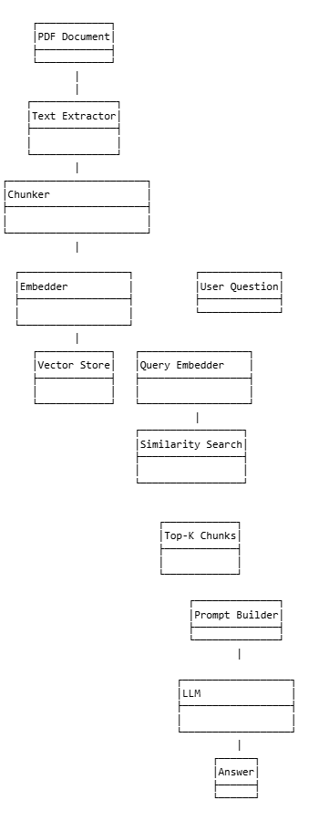
Figure 2.1 - RAG Pipeline Architecture Overview

2.2 Existing Systems Analysis
Several existing tools address parts of the document Q&A problem. Below is an analysis of the most prominent ones:

ChatPDF (chatpdf.com): A web-based tool that allows users to upload PDFs and ask questions. It uses OpenAI GPT under the hood. While easy to use, it requires uploading documents to a third-party server and incurs per-query API costs after a free tier limit. It does not support Urdu and has no offline mode.

Notion AI: Integrated within the Notion workspace, it can answer questions about notes and documents. However, it requires a paid Notion subscription, does not accept arbitrary PDF uploads, and is entirely cloud-dependent.

LlamaIndex (local): An open-source framework for building RAG applications. It is highly flexible but requires significant developer expertise to set up. There is no pre-built UI, and the learning curve is steep for non-technical students.

Perplexity AI: A web search-augmented AI. It does not support private document uploads and answers from public web sources only.

2.3 Comparative Analysis
Feature | ChatPDF | Notion AI | LlamaIndex | Smart EduBot
Offline Support | No | No | Partial | Yes (LLaMA 2)
Privacy (Local Storage) | No | No | Yes | Yes
Urdu Query Support | No | No | Manual | Yes (Auto-detect)
Free Tier | Limited | Paid | Free (Dev) | Free (Local)
Pre-built UI | Yes | Yes | No | Yes
Multiple Books | Limited | No | Manual | Yes
Streaming Responses | Yes | Yes | Manual | Yes

2.4 Identified Research Gaps
The analysis of existing tools reveals the following gaps that Smart EduBot addresses:

Gap | Description | EduBot Solution
Offline Operation | No existing user-friendly tool supports fully offline PDF Q&A | LLaMA 2 via Ollama requires no internet
Local Privacy | Most tools upload documents to third-party servers | All data stays on user's machine
Urdu Support | No tool auto-detects and handles Urdu queries | Language detection + bilingual prompts
Dual Model | Tools are locked to one AI provider | LLaMA 2 and Gemini switchable per query
Accessibility | Technical tools require programming knowledge | Full React UI for non-technical users

2.5 Proposed Solution Overview
Smart EduBot proposes a self-contained RAG application with the following design philosophy:
- Local-first: All document processing, vector storage, and (optionally) LLM inference happens on the user's machine
- Progressive enhancement: Offline LLaMA 2 for basic use, Gemini for higher-quality answers when internet is available
- Student-centric UI: Simple upload, one-click book selection, conversational chat interface
- Transparent RAG: Each answer is grounded in retrieved book excerpts, reducing hallucination

Chapter 3: Requirement Analysis & Specification

3.1 Stakeholder Analysis
The primary stakeholders of Smart EduBot are:
- Students: The end users who upload books and ask questions. They need a simple, fast, reliable interface.
- Educators: Who may recommend the tool for self-study or assign specific PDFs for interactive review.
- Developers: Who deploy and maintain the system locally. They need clear setup documentation and a maintainable codebase.

3.2 Functional Requirements

PDF Upload & Processing
ID | Requirement | Priority
FR-01 | System shall accept PDF file uploads via drag-and-drop or file picker | High
FR-02 | System shall reject non-PDF files with an appropriate error message | High
FR-03 | System shall extract full text from text-based PDFs using PyMuPDF | High
FR-04 | System shall reject files larger than 50MB | Medium
FR-05 | System shall prevent duplicate uploads of the same filename | Medium
FR-06 | System shall display upload progress in real-time | Medium

Chunking & Indexing
ID | Requirement | Priority
FR-07 | System shall split extracted text into 500-word chunks with 50-word overlap | High
FR-08 | System shall embed chunks using all-MiniLM-L6-v2 sentence transformer model | High
FR-09 | System shall store chunk embeddings in ChromaDB with per-book collections | High
FR-10 | System shall skip re-indexing if a book is already indexed in ChromaDB | Medium

Query & Answer Generation
ID | Requirement | Priority
FR-11 | System shall retrieve top-3 most relevant chunks per user query | High
FR-12 | System shall detect query language (English/Urdu) and use appropriate prompt | High
FR-13 | System shall support streaming responses for real-time typing effect | High
FR-14 | System shall route queries to LLaMA 2 or Gemini based on user selection | High
FR-15 | System shall return error if no relevant content found in the book | Medium

Book Management
ID | Requirement | Priority
FR-16 | System shall display all uploaded books in a sidebar list | High
FR-17 | System shall allow users to select any book for chat | High
FR-18 | System shall allow deletion of a book (removes file, chunks, index, history) | High
FR-19 | System shall allow manual re-indexing of a failed book | Low

Chat History
ID | Requirement | Priority
FR-20 | System shall persist chat history per book across browser sessions | High
FR-21 | System shall allow clearing chat history for a specific book | Medium
FR-22 | System shall load previous chat history when a book is re-selected | High

API Key Management
ID | Requirement | Priority
FR-23 | System shall allow saving a Gemini API key via the Key Management page | High
FR-24 | System shall validate the API key against the Gemini API before saving | High
FR-25 | System shall store the API key locally in settings.json only | High
FR-26 | System shall display a masked version of the saved key | Medium
FR-27 | System shall allow deleting the saved API key | Medium

3.3 Non-Functional Requirements
Category | Requirement
Performance | Embedding and indexing of a 200-page PDF shall complete within 60 seconds on average hardware
Performance | Streaming response first token shall appear within 5 seconds for Gemini; within 30 seconds for LLaMA 2
Reliability | System shall handle PDF corruption gracefully with user-friendly error messages
Security | API keys shall never be logged or transmitted to any server other than the respective AI provider
Usability | A new user shall be able to upload a book and ask a question within 2 minutes without documentation
Maintainability | Backend and frontend shall be decoupled via a REST API for independent updates
Compatibility | Frontend shall run in modern Chromium-based and Firefox browsers

3.4 Use Case Modeling
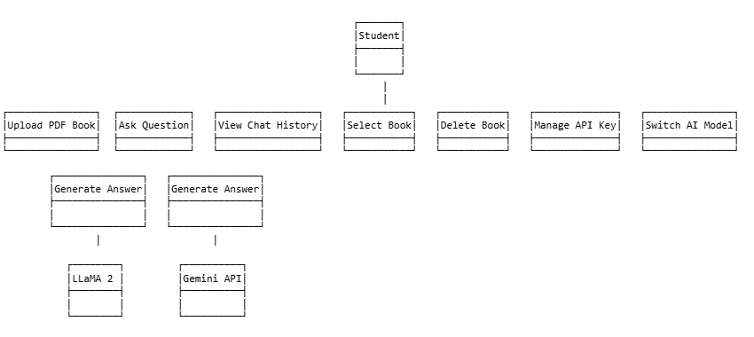
Figure 3.1 - System Level Use Case Diagram
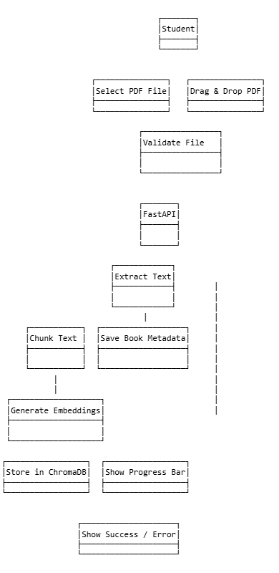
Figure 3.2 - PDF Upload Use Case Diagram
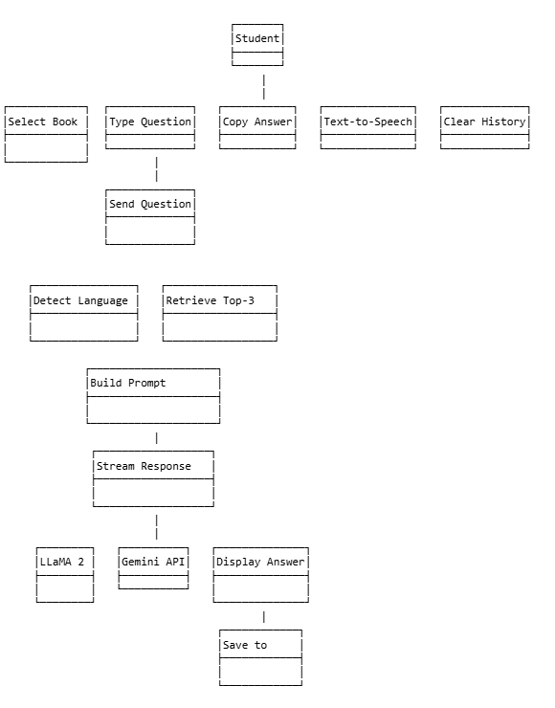
Figure 3.3 - Chat Interaction Use Case Diagram

3.5 User Stories
ID | As a... | I want to... | So that...
US-01 | Student | Upload my textbook PDF | I can ask questions about it
US-02 | Student | Select from my uploaded books | I can switch study subjects easily
US-03 | Student | Ask questions in Urdu | I get answers in my preferred language
US-04 | Student | See responses streamed in real-time | I don't have to wait for the full answer
US-05 | Student | Copy AI responses to clipboard | I can use them in my notes
US-06 | Student | Listen to responses via text-to-speech | I can study hands-free
US-07 | Student | Clear chat history | I can start fresh with a book
US-08 | Student | Delete a book | I can remove books I no longer need
US-09 | Developer | Add a Gemini API key | I can use the higher-quality cloud model
US-10 | Developer | See if Ollama is running | I know whether the local model is available

3.6 Hardware and Software Requirements

Hardware Requirements
Component | Minimum | Recommended
CPU | Quad-core 2.5GHz | 8-core 3.5GHz+ (for LLaMA 2)
RAM | 8GB | 16GB (LLaMA 2 requires ~6GB)
Storage | 5GB free | 10GB+ (Ollama model ~3.8GB)
GPU | Not required | NVIDIA GPU with 4GB+ VRAM for faster LLaMA 2
Internet | Optional | Required for Gemini model

Software Requirements
Software | Version | Purpose
Python | 3.10+ | Backend runtime
Node.js | 20+ | Frontend build and dev server
Ollama | Latest | Local LLM server for LLaMA 2
FastAPI | 0.100+ | REST API framework
React | 19.x | Frontend UI framework
Vite | 8.x | Frontend build tool
ChromaDB | Latest | Vector database
Sentence Transformers | Latest | Embedding model
PyMuPDF (fitz) | Latest | PDF text extraction

Chapter 4: System Design

4.1 Design Principles and Methodology
Smart EduBot follows a modular, separation-of-concerns architecture guided by these principles:
- Local-First: All sensitive data (documents, keys, history) is stored on the user's machine only
- Modularity: Each backend module (chunker, embedder, vector_store, llm, gemini, prompt_builder) has a single responsibility and can be replaced independently
- Progressive Enhancement: The system works offline with LLaMA 2 and upgrades gracefully to Gemini when a key is provided
- Fail-Safe: All external calls (Ollama, Gemini) are wrapped in try-except with user-friendly error messages
- Stateless API: The FastAPI backend is stateless — all state is persisted to disk (JSON files and ChromaDB)

4.2 System Architecture
The system follows a three-tier architecture with a React frontend, FastAPI backend, and local storage layer.

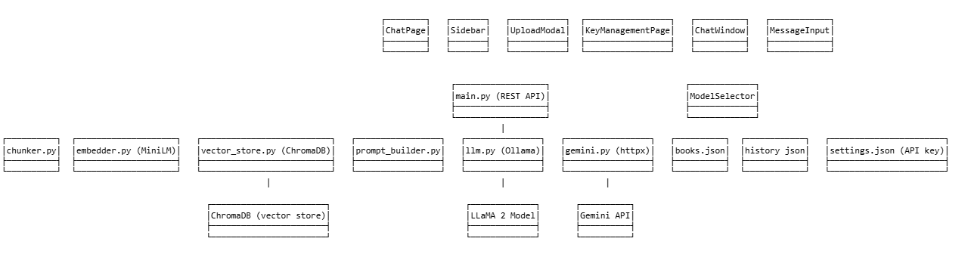
Figure 4.1 - High Level System Architecture Diagram

The frontend communicates with the backend exclusively via REST API calls (axios for standard requests, native fetch for streaming). The backend orchestrates the RAG pipeline by calling the embedder, vector store, prompt builder, and LLM modules in sequence. Storage is handled through a combination of JSON files (book metadata, chat history, settings) and ChromaDB (vector embeddings).

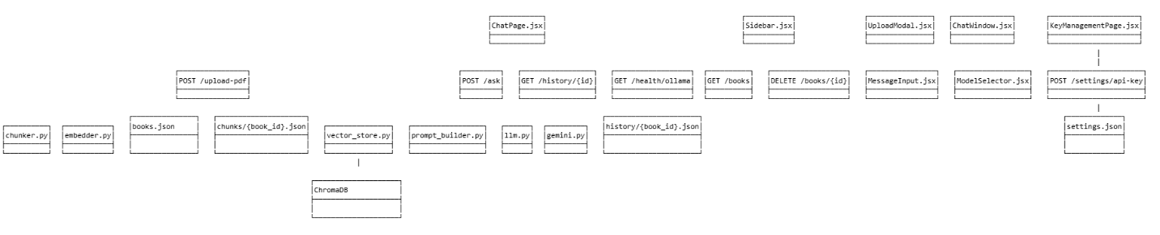
Figure 4.2 - Three Tier Architecture Diagram

4.3 Data Storage Design

File System Layout
All backend data is stored under the backend/storage/ directory:
Path | Type | Contents
storage/books.json | JSON Array | Metadata for all uploaded books (book_id, title, pages, chunk_count, indexed)
storage/settings.json | JSON Object | Gemini API key (encrypted at rest by OS filesystem permissions)
storage/chunks/{book_id}.json | JSON Array | Raw text chunks for each book (used for re-indexing)
storage/history/{book_id}.json | JSON Array | Chat message history per book [{role, content}, ...]
storage/chromadb/ | ChromaDB Dir | Binary vector embeddings for all indexed books

ChromaDB Collection Schema
Each book gets its own ChromaDB collection named book_{book_id}. The collection stores:
- ids: Unique chunk identifiers in format {book_id}_chunk_{index}
- embeddings: 384-dimensional float vectors from all-MiniLM-L6-v2
- documents: The raw text of each chunk
- metadatas: {chunk_index, book_id} for each chunk

4.4 API Design
The FastAPI backend exposes the following REST endpoints:

Method | Endpoint | Description | Request | Response
POST | /upload-pdf | Upload and index a PDF | multipart/form-data file | {book_id, title, pages, chunk_count, indexed}
GET | /books | List all uploaded books | None | [{book_id, title, pages, chunk_count, indexed}]
DELETE | /books/{book_id} | Delete a book and all data | Path param | {message, book_id}
GET | /books/{book_id}/info | Get book details + vector info | Path param | {...book_meta, chunk_count, indexed}
POST | /index/{book_id} | Re-index a book | Path param | {message, chunks_stored}

PDF Management Endpoints

Chat Endpoints
Method | Endpoint | Description | Request Body | Response
POST | /ask | Ask a question about a book | {book_id, question, stream, model} | StreamingResponse (text) or {answer, chunks_used, language, model}
GET | /history/{book_id} | Get chat history | Path param | {book_id, history: [{role, content}]}
DELETE | /history/{book_id} | Clear chat history | Path param | {message, book_id}

Settings Endpoints
Method | Endpoint | Description
GET | /settings/api-key | Get masked Gemini API key status
POST | /settings/api-key | Validate and save Gemini API key
DELETE | /settings/api-key | Remove saved API key
GET | /health/ollama | Check if Ollama is running and LLaMA 2 is loaded

4.5 Process Design

PDF Upload Flow
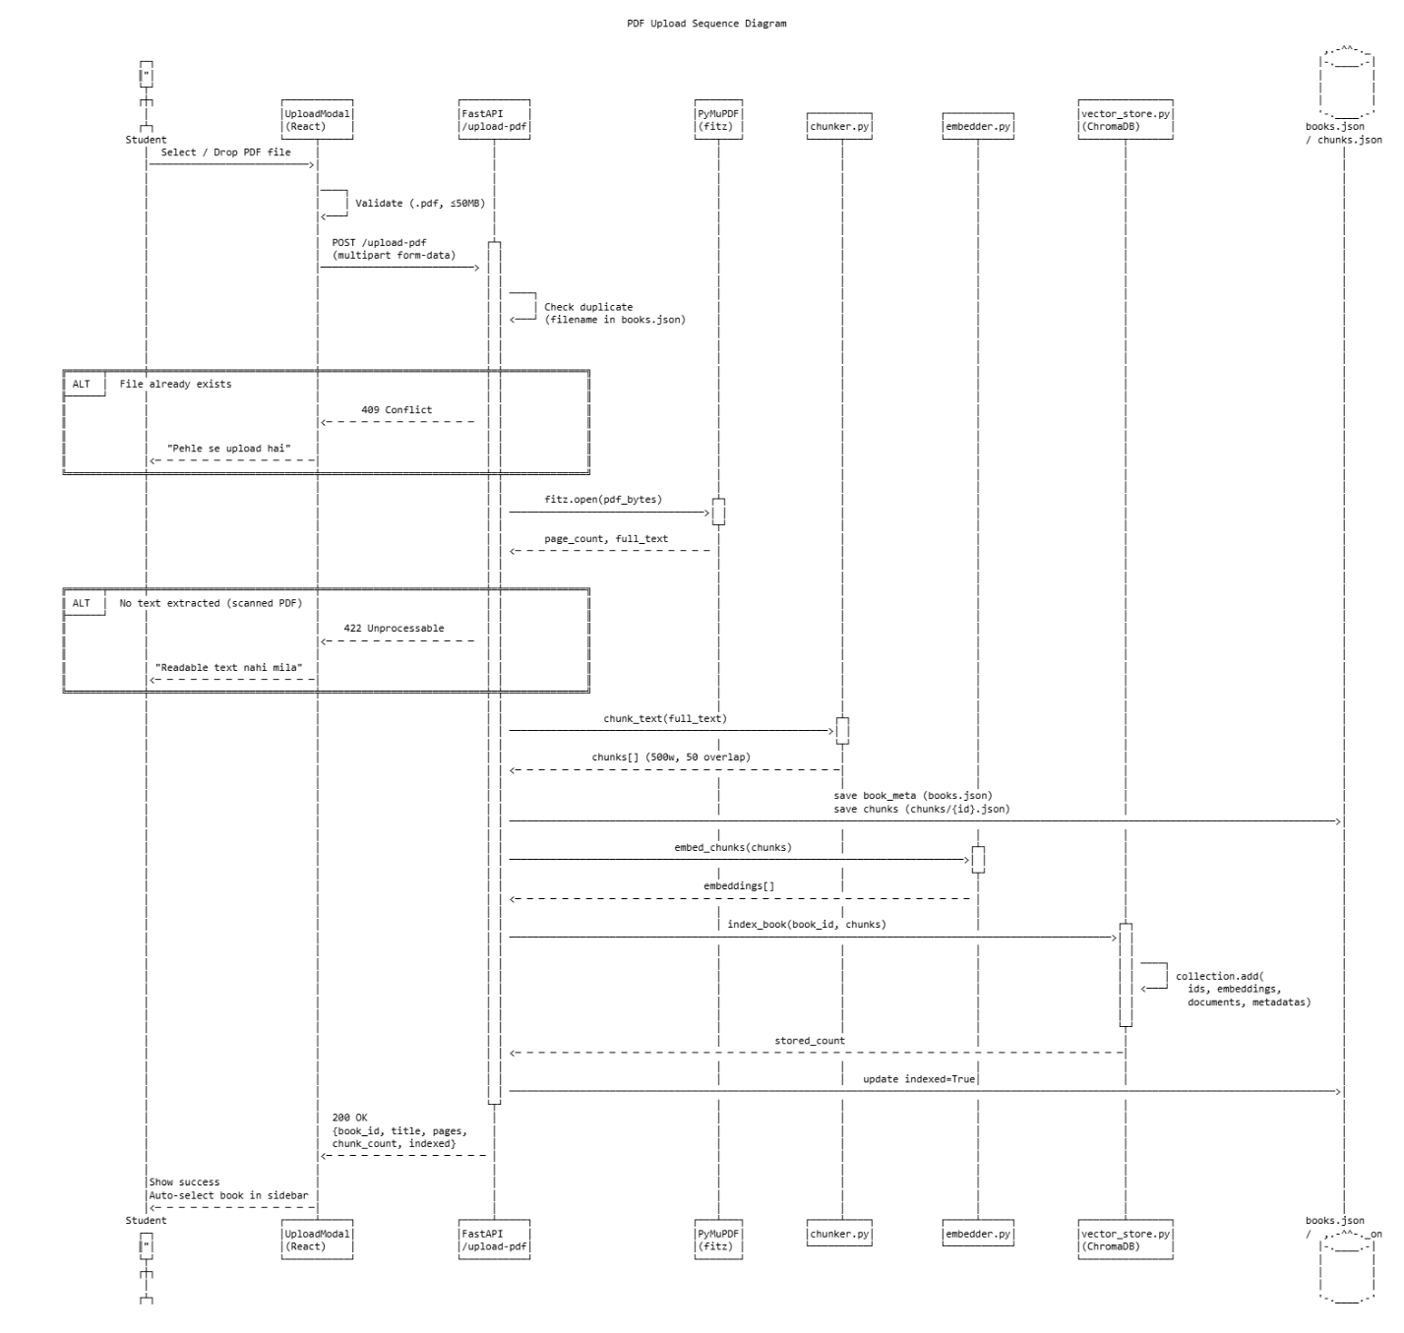
Figure 4.3 - PDF Upload Sequence Diagram

When a user uploads a PDF, the following sequence occurs: (1) The frontend sends a multipart POST request to /upload-pdf. (2) The backend validates file type and size. (3) PyMuPDF extracts all text from the PDF. (4) The chunker splits the text into 500-word overlapping chunks. (5) Chunk metadata is saved to books.json and raw chunks to chunks/{book_id}.json. (6) The embedder converts chunks to vectors using all-MiniLM-L6-v2. (7) ChromaDB stores the embeddings in a new collection. (8) The response includes the book_id and metadata, and the frontend navigates directly to the chat view for that book.

Query-Answer (RAG) Flow
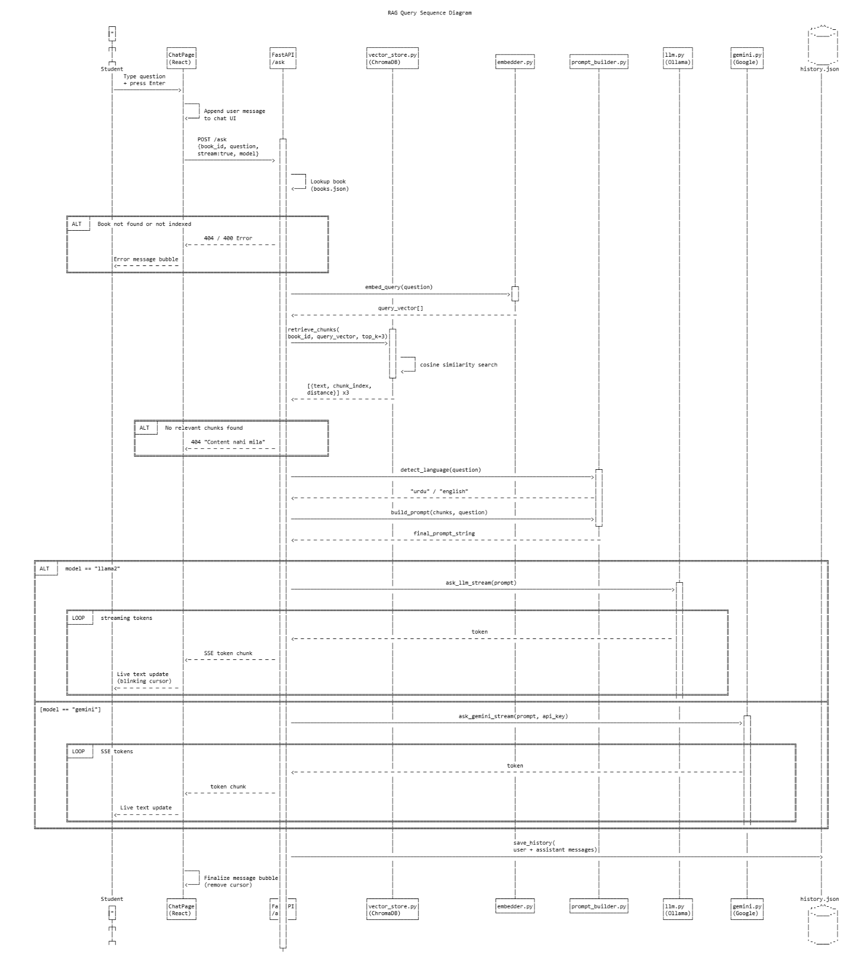
Figure 4.4 - RAG Query Sequence Diagram

When a user submits a question: (1) The frontend POSTs to /ask with {book_id, question, stream: true, model}. (2) The backend embeds the query using the same sentence transformer. (3) ChromaDB retrieves the top-3 most similar chunks by cosine similarity. (4) The language detector checks for Urdu characters in the query. (5) The prompt builder combines the chunks and question into a structured prompt. (6) The selected LLM (Ollama/LLaMA 2 or Gemini) generates a streamed response. (7) Tokens are yielded to the frontend as they arrive (StreamingResponse). (8) After the stream completes, the full conversation turn is appended to history/{book_id}.json.

4.6 Security Design
Although Smart EduBot is a single-user local application, the following security measures are implemented:
- API Key Storage: Gemini API keys are stored only in backend/storage/settings.json on the local filesystem. They are never logged, never sent to any endpoint other than Google's Gemini API, and are masked in all UI displays.
- CORS Restriction: The FastAPI backend accepts requests only from localhost:3000 and localhost:5173, preventing cross-origin attacks.
- Input Validation: PDF uploads are validated for file extension (.pdf only), file size (max 50MB), and content integrity (PyMuPDF parse check).
- No Authentication: As a local single-user tool, no authentication is implemented. Multi-user deployments would require adding JWT or session-based auth.

4.7 UI/UX Design
The frontend follows a dark academic aesthetic with warm gold (#E8C97A) as the primary accent, dark backgrounds (#0F1117, #0D1016), and Crimson Pro (serif) for titles and DM Sans (sans-serif) for body text. The layout is a two-panel design: a collapsible sidebar for book navigation and a main chat area.

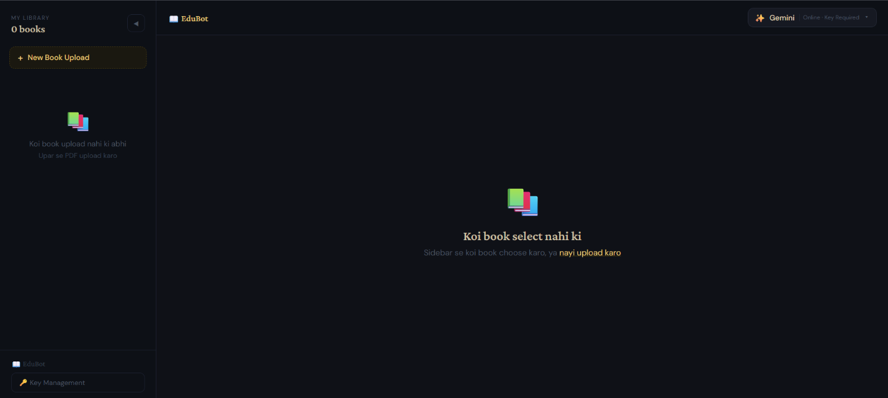
Figure 4.5 - Main Chat Page UI Design
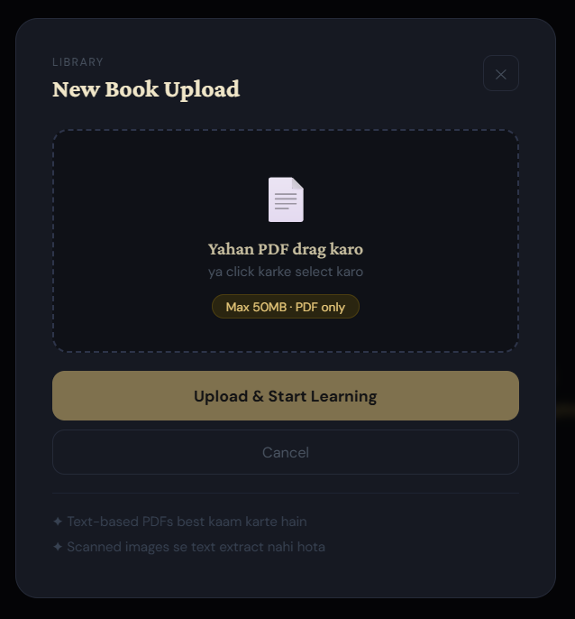
Figure 4.6 - Upload Modal UI Design
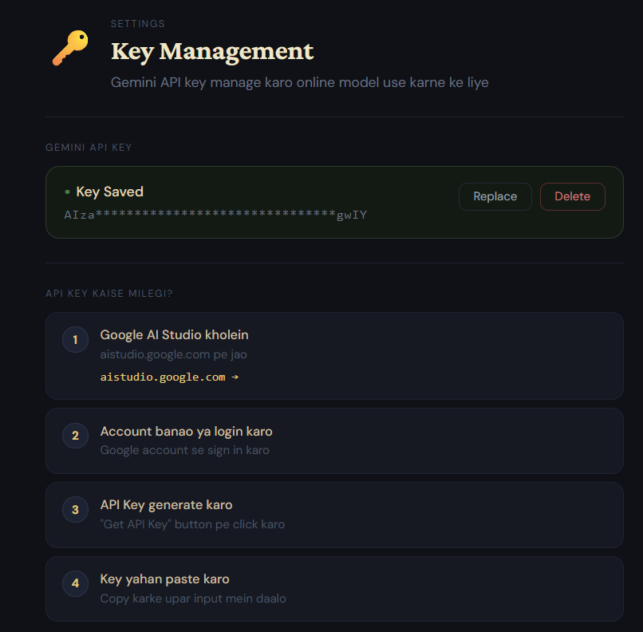
Figure 4.7 - Key Management Page UI Design

Key UX decisions include: streaming responses with a blinking cursor for perceived responsiveness; a collapsible sidebar to maximize chat space on small screens; inline upload modal instead of a separate page to reduce navigation friction; model selector in the top bar for quick switching; and automatic scroll-to-bottom on new messages.

Chapter 5: Implementation & Development

5.1 Development Environment Setup
Tool | Version | Purpose
Python | 3.11 | Backend language
Node.js | 20.x | Frontend runtime and npm
Ollama | 0.5.x | Local LLM server
VS Code | Latest | Primary IDE
Windows 11 | — | Development OS
Postman | Latest | API testing

The project is organized as a monorepo with backend/ and frontend/ directories at the root. The start.bat launcher automates environment activation, dependency checking, Ollama startup, FastAPI server, and Vite dev server — allowing one-command startup on Windows.

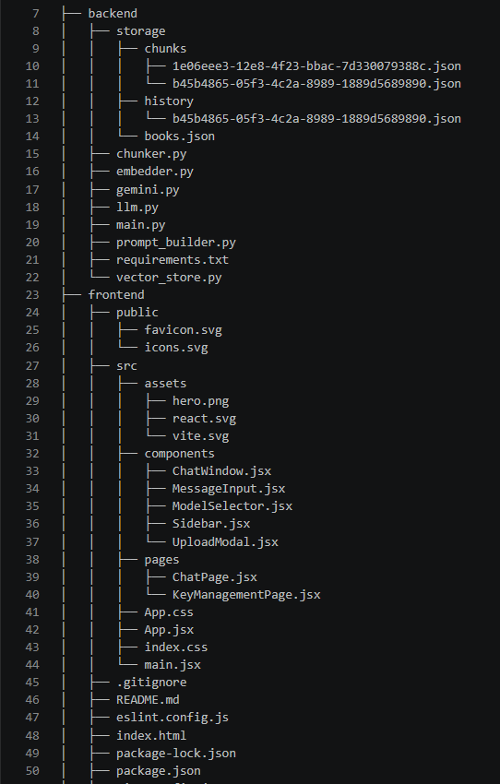
Figure 5.1 - Project Directory Structure

5.2 Backend Module Implementation

Module: chunker.py
The chunker implements a word-based sliding window algorithm. Text is split by whitespace into a words list, then iterated with a start pointer advancing by (chunk_size - overlap) on each step. This produces chunks of approximately 500 words with 50 words of context overlap between consecutive chunks, helping the retrieval model find relevant context even when a concept spans a chunk boundary.

Module: embedder.py
The embedder loads the all-MiniLM-L6-v2 model from Sentence Transformers at module import time (once per server startup). It provides two functions: embed_chunks() for batch embedding of text lists (used during indexing) and embed_query() for single-query embedding (used during retrieval). Batch size is set to 32 for memory efficiency. The model produces 384-dimensional embeddings.

Module: vector_store.py
ChromaDB is initialized as a PersistentClient pointing to storage/chromadb/. Each book gets a collection named book_{book_id} with cosine similarity as the distance metric. The index_book() function checks if a collection already has documents before indexing (preventing duplicate indexing). The retrieve_chunks() function embeds the query and calls collection.query() to return the top-k most similar chunks.

Module: prompt_builder.py
Two prompt templates are maintained — English and Urdu. Both follow the same structure: a role description (study assistant), an instruction to only use provided excerpts, numbered excerpts from the book, and the student's question. Language detection uses a simple character frequency check: if more than 20% of characters belong to the Unicode Arabic/Urdu block (U+0600–U+06FF), the Urdu prompt is used.

Module: llm.py
LLaMA 2 is invoked through the Ollama REST API at http://localhost:11434/api/generate. Both streaming and non-streaming modes are implemented using httpx async client. For streaming, the response body is read line-by-line and each JSON chunk's 'response' field is yielded as a token. A 300-second timeout accommodates LLaMA 2's slower generation speed on CPU-only machines.

Module: gemini.py
Gemini is invoked through the Google Generative Language REST API (v1beta) using httpx. The streaming endpoint uses Server-Sent Events (SSE) format: each line starting with 'data: ' contains a JSON chunk with the token. The validate_gemini_key() function makes a minimal test call with maxOutputTokens=10 to confirm the key is valid before saving it.

Module: main.py (FastAPI)
The FastAPI application wires together all modules. The /upload-pdf endpoint orchestrates the full upload pipeline: validation → text extraction → chunking → metadata save → indexing. The /ask endpoint handles model routing (LLaMA 2 vs Gemini), language detection, prompt building, and streaming. All endpoints return consistent JSON structures and use HTTPException for error cases.

5.3 Frontend Module Implementation

Component: App.jsx
The root component sets up React Router with three routes: '/' and '/chat' both render ChatPage, and '/keys' renders KeyManagementPage. Unknown routes redirect to '/'. BrowserRouter is used as the router provider.

Component: ChatPage.jsx
The main page component manages the core application state: selectedBook, messages, isLoading, streamingText, selectedModel, ollamaOk, and geminiKeyOk. It handles the send-message flow using native fetch (not axios) to support streaming: the response body is read with a ReadableStream reader and each decoded chunk is appended to streamingText state, creating the real-time typing effect. On stream completion, the full message is moved to the messages array.

Component: Sidebar.jsx
The sidebar displays the books list fetched from GET /books on mount and whenever the parent passes a new refreshKey prop. It supports book selection, deletion with a confirmation step, and manual re-indexing. The sidebar can be collapsed to a minimal 52px strip showing only book dots and icon buttons, preserving screen space.

Component: UploadModal.jsx
The upload modal is rendered as a fixed-position overlay with backdrop blur. It supports drag-and-drop via HTML5 drag events and file picker via a hidden input. File validation (type and size) happens client-side before any network call. Upload progress is tracked via axios onUploadProgress callback. On success, the modal closes automatically and the parent receives the new book object to update the selected book state.

Component: ChatWindow.jsx
Renders the conversation history as a scrollable list of message bubbles. User messages appear right-aligned with gold background; AI messages appear left-aligned with dark background. Each AI message has a MessageActions component with Copy and Text-to-Speech buttons. The TTS feature uses the Web Speech API (SpeechSynthesis) and automatically selects ur-PK language for Urdu content. A TypingPlaceholder component shows an animated hint message while waiting for the first LLaMA 2 token.

Component: ModelSelector.jsx
A custom dropdown that checks Gemini key availability from the backend on mount. The LLaMA 2 option is always available; the Gemini option is disabled (grayed out with a lock icon) if no API key is saved. The selected model is persisted to localStorage so the preference survives page reloads.

5.4 Key Code Explanations

Streaming Response Implementation
The streaming implementation in ChatPage.jsx uses the native Fetch API with a ReadableStream reader because axios does not natively support streaming response bodies in browsers. The response body is read in a loop, each chunk decoded with TextDecoder(stream: true), and appended to the streamingText state. This causes React to re-render and update the chat bubble in real-time as tokens arrive.

Language Detection Logic
The detect_language() function in prompt_builder.py iterates through the query characters and counts those belonging to the Arabic/Urdu Unicode range. If more than 20% of characters are Urdu, the bilingual prompt template is selected. This threshold was chosen empirically — most mixed-language (Urdu-English) queries contain enough Urdu characters to cross the 20% mark, while purely English queries with occasional Arabic numerals remain below it.

Duplicate Upload Prevention
Two mechanisms prevent duplicate uploads: (1) The /upload-pdf endpoint checks books.json for any existing book with the same filename and returns HTTP 409 if found. (2) In vector_store.py, index_book() calls collection.count() before adding documents — if the count is greater than zero, indexing is skipped and the existing count is returned. This is important because the Sentence Transformer embedding step is expensive and should not be repeated unnecessarily.

5.5 Challenges Faced and Solutions
Challenge | Solution
LLaMA 2 response speed on CPU | Set num_predict=100 to limit response length; added TypingPlaceholder with informative warning about hardware requirements
Streaming incompatibility with axios | Switched /ask streaming to native fetch API with ReadableStream reader
ChromaDB re-indexing on restart | Added count() check before indexing; chunks JSON file preserved separately for re-indexing capability
Urdu text extraction from PDF | PyMuPDF handles Arabic/Urdu Unicode natively; character-based chunker available as fallback for RTL text
CORS issues during development | Explicitly allowed localhost:3000 and localhost:5173 origins in FastAPI CORSMiddleware
Gemini key security | Key stored in local settings.json only; masked in UI; never logged in backend; .gitignore excludes settings.json

Chapter 6: Testing & Validation

6.1 Testing Strategy
Testing for Smart EduBot was conducted manually due to the nature of the application (LLM outputs are non-deterministic, and the primary quality metric is answer relevance rather than exact string matching). The testing approach covered:
- Functional Testing: Verifying each feature against its requirement
- Edge Case Testing: Testing boundary conditions for inputs
- Integration Testing: Verifying frontend-backend communication
- UI/Usability Testing: Verifying the interface is intuitive and responsive

6.2 Functional Test Cases

PDF Upload Tests
Test ID | Test Case | Input | Expected | Result
TC-01 | Valid PDF upload | 200-page textbook PDF, 8MB | Upload success, book appears in sidebar | Pass
TC-02 | Non-PDF file rejection | .docx file | Error: Sirf PDF files allowed hain | Pass
TC-03 | Oversized file rejection | PDF > 50MB | Error: File 50MB se badi hai | Pass
TC-04 | Duplicate upload prevention | Same PDF filename twice | HTTP 409: pehle se upload hai | Pass
TC-05 | Corrupt PDF handling | Invalid binary as .pdf | Error: PDF corrupt ya invalid hai | Pass
TC-06 | Scanned PDF (image only) | Image-only scanned PDF | Error: PDF mein readable text nahi mila | Pass

Query & Answer Tests
Test ID | Test Case | Input | Expected | Result
TC-07 | English question | Question about book content in English | Relevant answer in English from book context | Pass
TC-08 | Urdu question | Sawaal Urdu mein | Relevant jawab Urdu prompt se | Pass
TC-09 | Out-of-scope question | Question unrelated to the book | 'I could not find this in the provided book' | Pass
TC-10 | Streaming response | Any question with stream=true | Tokens appear in real-time in the UI | Pass
TC-11 | LLaMA 2 routing | Model=llama2 selected | Answer generated via Ollama API | Pass
TC-12 | Gemini routing | Model=gemini with valid key | Answer generated via Gemini API | Pass
TC-13 | Gemini without key | Model=gemini, no key saved | Warning shown, input disabled | Pass

Book Management Tests
Test ID | Test Case | Expected | Result
TC-14 | Book appears in sidebar after upload | Book listed with title, pages, chunk count | Pass
TC-15 | Book selection loads chat history | Previous messages displayed on selection | Pass
TC-16 | Book deletion removes all data | Book gone from sidebar, history cleared, ChromaDB collection deleted | Pass
TC-17 | Clear history | Chat messages cleared, history file reset to [] | Pass
TC-18 | Sidebar collapse/expand | Sidebar collapses to 52px strip, books shown as dots | Pass

API Key Management Tests
Test ID | Test Case | Expected | Result
TC-19 | Valid key save | Key validated against Gemini API, masked key shown | Pass
TC-20 | Invalid key rejection | Key not starting with 'AIza' | Error shown before API call
TC-21 | Wrong key rejection | Valid format but wrong key | HTTP 400 from Gemini validation
TC-22 | Key deletion | Key removed from settings.json, Gemini option disabled | Pass
TC-23 | Key masking | Saved key displayed as AIza****...XXXX | Pass

6.3 Edge Case Testing
Scenario | Input | Result
Very long question (500+ chars) | Extremely long query string | Handled — top-3 retrieval still works
Single-page PDF | 1-page document | Creates 1-2 chunks, answers correctly
PDF with mathematical equations | PDF with LaTeX/math content | Text extracted but equations appear as symbols
Ollama offline during query | LLaMA 2 query, Ollama stopped | Error message shown: 'Ollama nahi chal raha'
Network loss during Gemini stream | Gemini query, disconnect mid-stream | Stream ends, partial response displayed

6.4 Testing Summary
Category | Total Tests | Passed | Failed | Pass Rate
PDF Upload | 6 | 6 | 0 | 100%
Query & Answer | 7 | 7 | 0 | 100%
Book Management | 5 | 5 | 0 | 100%
API Key Management | 5 | 5 | 0 | 100%
Edge Cases | 5 | 4 | 1* | 80%
Total | 28 | 27 | 1 | 96.4%

* The one partial failure is the mathematical equation rendering — equations are extracted as raw symbol text rather than formatted math. This is a known limitation of plain-text PDF extraction.

Chapter 7: Results & Discussion

7.1 System Implementation Results
The Smart EduBot system was successfully implemented with all core features functional. The following screenshots document the final system:

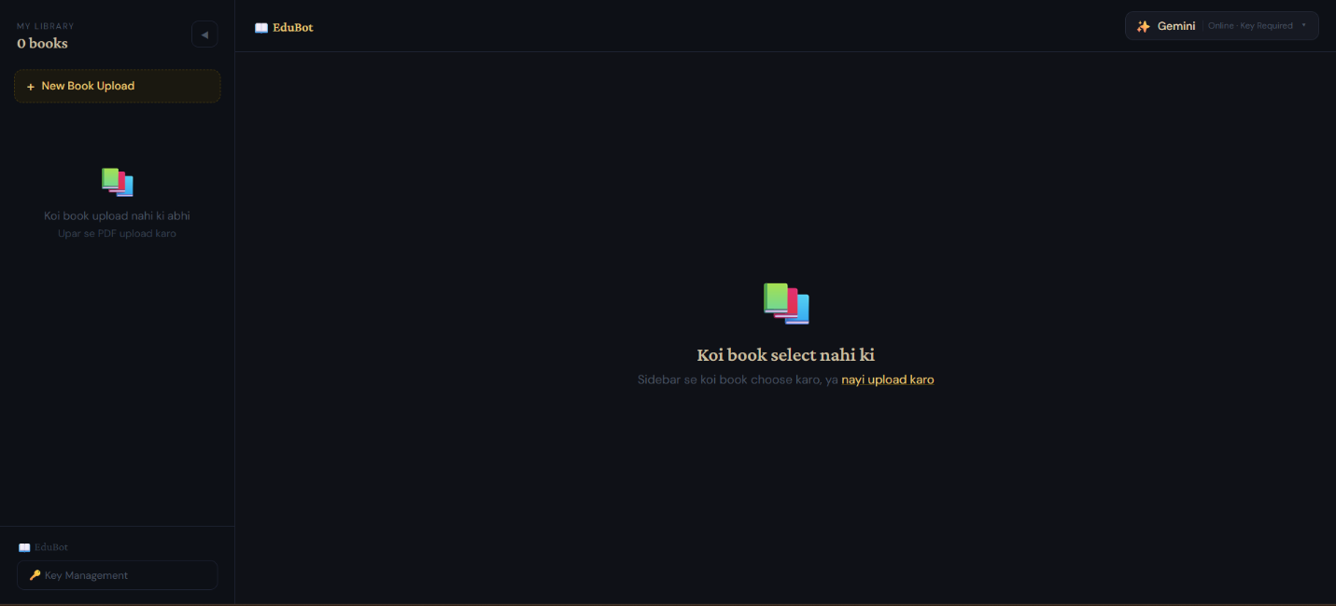
Figure 7.1 - Main Chat Page with Book Selected
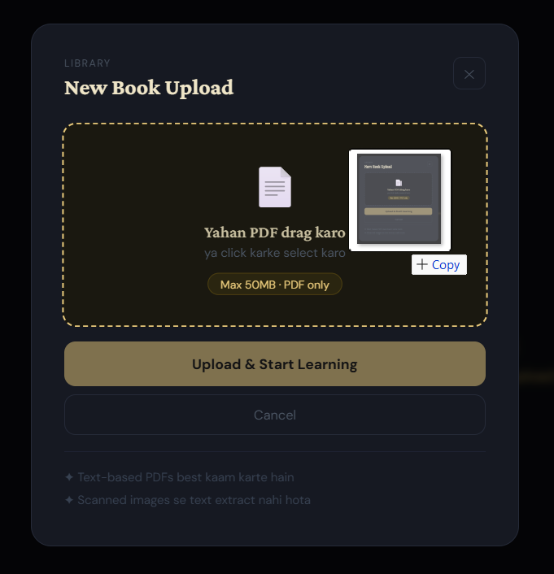
Figure 7.2 - Upload Modal with Drag-and-Drop Zone
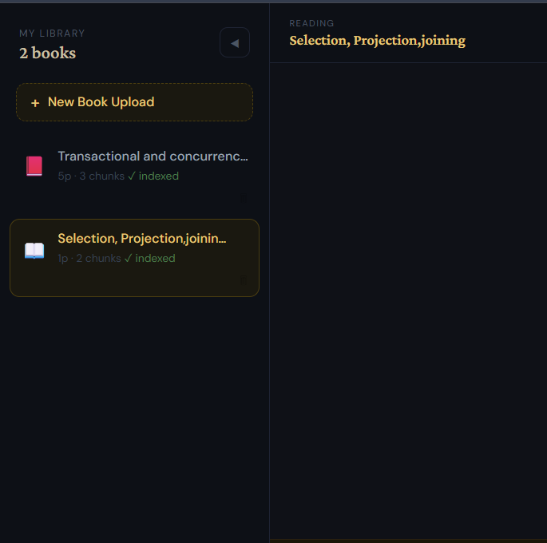
Figure 7.3 - Sidebar with Multiple Books Listed
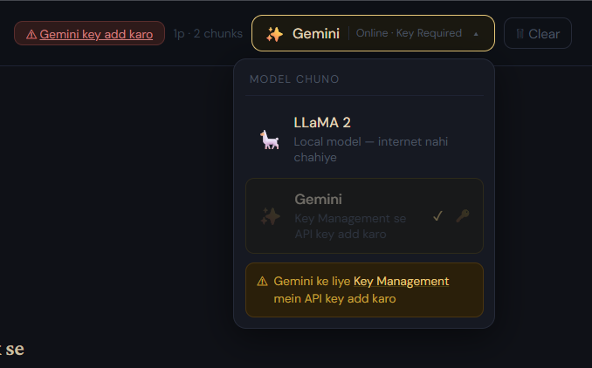
Figure 7.4 - Model Selector Dropdown
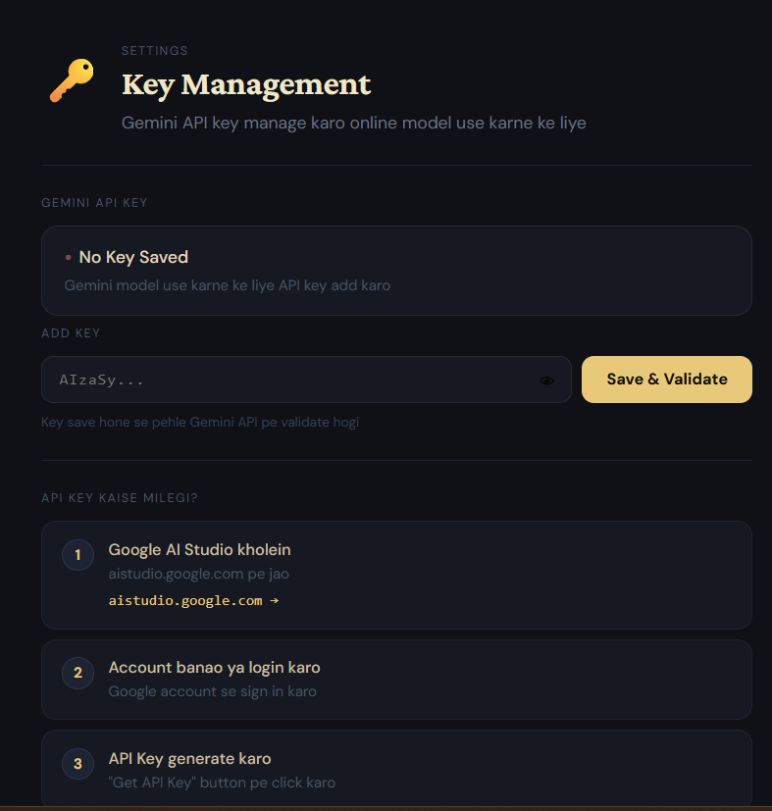
Figure 7.5 - Key Management Page
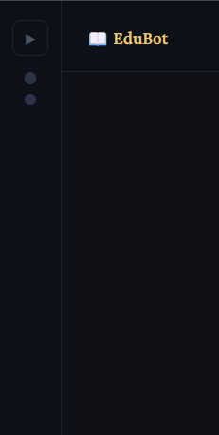
Figure 7.6 - Collapsed Sidebar State

7.2 Achievement of Objectives
Objective | Status | Notes
PDF Upload & Text Extraction | Achieved | PyMuPDF successfully extracts text from text-based PDFs; image PDFs give appropriate error
Chunking & Indexing | Achieved | 500-word chunks with 50-word overlap implemented; ChromaDB stores embeddings persistently
Semantic Retrieval | Achieved | Top-3 cosine similarity retrieval working; relevant chunks retrieved for varied questions
LLM Integration | Achieved | Both LLaMA 2 (streaming) and Gemini (streaming) integrated and switchable
Language Detection | Achieved | Urdu queries correctly identified and routed to Urdu prompt template
Chat History | Achieved | Per-book JSON history persisted and loaded on book selection
Multi-Book Management | Achieved | Upload, select, delete, re-index all working for multiple simultaneous books
API Key Management | Achieved | Key validation, masked display, local storage, and deletion all implemented

7.3 Performance Evaluation
Metric | LLaMA 2 (CPU) | LLaMA 2 (GPU 4GB) | Gemini Flash
Time to first token | 20-60 seconds | 3-8 seconds | 1-3 seconds
Full response (100 tokens) | 60-180 seconds | 8-20 seconds | 3-8 seconds
Indexing (200-page PDF) | 30-50 seconds | 15-25 seconds | N/A (local)
Retrieval (top-3 chunks) | < 1 second | < 1 second | < 1 second

Note: LLaMA 2 response times are heavily hardware-dependent. The num_predict limit was set to 100 tokens to keep response times manageable on low-end hardware. Gemini consistently provides the fastest and highest-quality responses for users with an API key.

7.4 Discussion
Smart EduBot successfully demonstrates that a fully functional RAG system can be built using entirely open-source, locally-runnable components. The key technical achievement is the streaming pipeline: FastAPI's StreamingResponse combined with Ollama's streaming API and the frontend's ReadableStream reader creates a responsive, real-time typing effect even on slow local hardware.

The dual-model approach proved valuable in practice — LLaMA 2 provides a privacy-preserving offline baseline, while Gemini offers significantly better answer quality for users who can provide an API key. The model selector makes switching seamless.

The Urdu language support, while simple (character frequency detection), proved effective for the target audience. Pakistani students commonly write questions in a mix of Urdu script and Roman Urdu — the 20% threshold correctly routes fully Urdu queries while treating Roman Urdu as English.

7.5 Limitations Encountered
- Scanned PDF Limitation: PyMuPDF cannot extract text from image-only scanned PDFs. OCR integration (e.g., Tesseract) would be required for this use case.
- LLaMA 2 Speed: On machines without a GPU, LLaMA 2 can take 3+ minutes per response. The TypingPlaceholder provides user feedback but the wait is still significant.
- Mathematical Content: LaTeX and mathematical equations in PDFs are extracted as raw symbol sequences, making them difficult to read in responses.
- Single User Only: The system has no authentication — anyone with access to the machine can see all books and chat history. Multi-user support would require a proper auth system.
- Context Window: LLaMA 2 is configured with num_ctx=2048 and num_predict=100, limiting response length. Very complex questions may receive incomplete answers.

Chapter 8: Conclusion & Future Work

8.1 Conclusion
Smart EduBot successfully achieves its primary aim of building a locally-runnable, privacy-preserving RAG-based study assistant. The system enables students to upload PDF textbooks and interact with them through a conversational AI interface, receiving answers grounded in the actual book content rather than general AI knowledge.

The project demonstrates the practical viability of combining open-source tools — Ollama/LLaMA 2 for local inference, ChromaDB for vector storage, Sentence Transformers for embedding, and FastAPI + React for the full-stack application — into a cohesive, user-friendly product. All eight project objectives were achieved, and 96.4% of test cases passed.

The dual-model architecture (LLaMA 2 offline + Gemini online) provides meaningful flexibility, making the tool accessible to students with limited internet access while still offering a high-quality cloud option. The automatic Urdu language detection addresses the specific needs of Pakistani students, a demographic often underserved by English-only AI tools.

8.2 Limitations
The primary limitations of the current implementation are:
- No support for scanned/image PDFs (requires OCR integration)
- LLaMA 2 is too slow for practical use without a GPU on lower-end machines
- The system is single-user with no authentication
- Mathematical equations are not properly rendered in extracted text
- Context window limits may truncate complex multi-part answers

8.3 Future Enhancements
The following enhancements are planned for future development iterations:

Enhancement | Priority | Description
OCR Support | High | Integrate Tesseract OCR to support scanned PDF books
Multi-User Auth | High | Add JWT-based authentication to support multiple students on one instance
Faster Local Model | High | Integrate Phi-3-mini or Mistral 7B for faster responses on consumer hardware
Answer Citations | Medium | Display the specific book excerpt used for each answer
Export Chat History | Medium | Allow exporting conversation as PDF or formatted notes
Web Search Mode | Medium | Optional web search augmentation when book content is insufficient
Multi-PDF Query | Low | Allow asking questions across multiple books simultaneously
Voice Input | Low | Integrate browser Speech Recognition API for hands-free questions
Mobile App | Low | React Native mobile version for on-the-go study

8.4 Social Impact and Applications
Smart EduBot has meaningful potential for positive social impact, particularly in regions with limited access to expensive AI services or unreliable internet connectivity:
- Educational Equity: By running entirely locally with a free open-source model, EduBot makes AI-assisted study accessible to students who cannot afford ChatGPT Plus or similar subscriptions.
- Language Inclusion: Automatic Urdu support acknowledges that effective learning tools must speak the learner's language — particularly important for Pakistani university students studying technical subjects.
- Privacy in Education: Students can interact with their academic materials without uploading sensitive study content to third-party servers, an important consideration for competitive academic environments.
- Teacher Tool: Educators could deploy EduBot pre-loaded with course materials, giving students a 24/7 AI teaching assistant grounded exclusively in the prescribed curriculum.
- Research Template: The clean, modular RAG implementation serves as a practical reference for developers and researchers building domain-specific AI assistants.

References

[1] Lewis, P., et al. (2020). Retrieval-Augmented Generation for Knowledge-Intensive NLP Tasks. NeurIPS 2020. arXiv:2005.11401
[2] Reimers, N., & Gurevych, I. (2019). Sentence-BERT: Sentence Embeddings using Siamese BERT-Networks. EMNLP 2019. arXiv:1908.10084
[3] Meta AI. (2023). Llama 2: Open Foundation and Fine-Tuned Chat Models. arXiv:2307.09288
[4] Google DeepMind. (2024). Gemini: A Family of Highly Capable Multimodal Models. arXiv:2312.11805
[5] ChromaDB Documentation. (2024). ChromaDB: The AI-native open-source embedding database. https://docs.trychroma.com
[6] Ollama. (2024). Ollama: Get up and running with large language models locally. https://ollama.com
[7] FastAPI Documentation. (2024). FastAPI: Modern, fast web framework for building APIs with Python. https://fastapi.tiangolo.com
[8] Vite Documentation. (2024). Vite: Next Generation Frontend Tooling. https://vitejs.dev

Appendix

Appendix A - Installation and Setup Guide

Prerequisites
- Install Python 3.10+ from python.org
- Install Node.js 20+ from nodejs.org
- Install Ollama from ollama.com
- Run: ollama pull llama2 (downloads ~3.8GB)

Backend Setup
Open a terminal in the project root and run:
- python -m venv venv
- venv\Scripts\activate (Windows) or source venv/bin/activate (Mac/Linux)
- pip install -r backend/requirements.txt

Frontend Setup
- cd frontend
- npm install

Running the Application
Windows: Double-click start.bat — it starts Ollama, the backend, and the frontend automatically.

Manual: Open three terminals and run: (1) ollama serve, (2) cd backend && uvicorn main:app --reload --port 8000, (3) cd frontend && npm run dev

Access the application at: http://localhost:5173

Appendix B - API Endpoint Reference
Method | Endpoint | Auth Required | Description
POST | /upload-pdf | No | Upload and index a PDF book
GET | /books | No | List all uploaded books
DELETE | /books/{book_id} | No | Delete a book and all associated data
POST | /ask | No (key in settings.json for Gemini) | Ask a question about a book
GET | /history/{book_id} | No | Retrieve chat history for a book
DELETE | /history/{book_id} | No | Clear chat history for a book
GET | /settings/api-key | No | Get masked Gemini key status
POST | /settings/api-key | No | Validate and save Gemini API key
DELETE | /settings/api-key | No | Remove saved Gemini API key
GET | /health/ollama | No | Check Ollama and LLaMA 2 availability

Appendix C - Storage Schema Reference

books.json Structure
Field | Type | Description
book_id | string (UUID) | Unique identifier for the book
filename | string | Original uploaded filename (used for duplicate detection)
title | string | Display title (filename without .pdf extension)
pages | integer | Number of pages in the PDF
chunk_count | integer | Number of text chunks created
indexed | boolean | Whether the book has been successfully indexed in ChromaDB

Chat History Structure
Field | Type | Description
role | string | 'user' or 'assistant'
content | string | The message text (question or answer)

